-



System design SPECIFICATION
for
Offence and Appeal module

Release No 2.0– May 2023

Document Identification no | Document Title | Status  (draft/ approved/ baselined/ released ) | Date of Release | Pages
eCMS /sds/01/V2.0 | System design specification for Registration

Prepared By
Role | Name | Signature | Date (dd-mm-yyyy)

Reviewed by

Role | Name | Signature | Date (dd-mm-yyyy)

Approved By
Role | Name | Signature | Date (dd-mm-yyyy)
application system Manager

Authorized for Release
 | Name | Designation | Signature | Date (dd-mm-yy)
Authorized by Project Manager

Contents
1. INTRODUCTION 4
1.1. Scope 4
1.2. Definitions and abbreviations 4
1.3. References 5
1.4. Product Perspective 5
2. Design viewpoints 5
2.1. Interface viewpoint 5
2.2. Dependency Viewpoint 10
2.3. System Database Schema (er diagram) 11
2.4. Field Details 12

INTRODUCTION

This document defines & illustrates the business requirements, process flows as well as the detailed functional requirements of eCMS Offence, Penalty, Appeal modules to be implemented for Department of Revenue and Customs, Bhutan. Also included are modules for Customs Warehouse for detained/seized/confiscated goods.

Enforcement allows customs to manage breach of Customs law, policies, and regulations. It can be triggered at clearance process. Enforcement is also known as Offence Management, and these are used interchangeably.

The function explains management of breach of Customs laws and regulations. The function includes notification of offenders, compounding of offences and waiver of interest on penalties.

Scope
The scope of the Offence module is as below:
- Offence Management
- Penalty
- Appeal
- Customs Warehouse

Definitions and abbreviations

Definitions & Abbreviations | Description
eCMS | Electronic Customs Management System
DRC | Department of Revenue & Custom
DITT | Department of Information Technology & Telecom
YK | Yang Khor
CL | Crimsonlogic
SIT | System Integration Test
UAT | User Acceptance Test
SRS | Software Requirements Specification
EIS | External Interface Specification
PD | Project Director
PM | Project Manager
QA | Quality Assurance
SI | System Integration
SME | Subject Matter Expert
QMS | Quality Management System
CR | Change Request
SCCB | Software Change Control Board
SQAR | Software Quality Assurance Representative
V&V AND VnV | Verification and Validation
CFA | Clearing and Forwarding Agent
BHW | Bonded Warehouse
TSO | Temporary Storage Operator
WHO | Warehouse Operator

References
Signed off SRS_eCMS_Registration_V1.0

Product Perspective
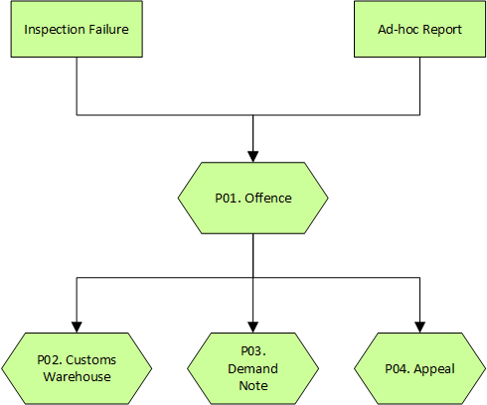

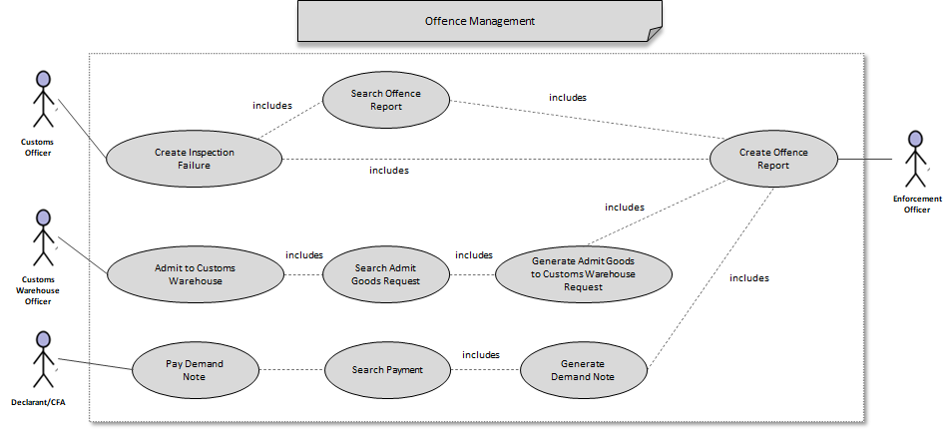

Design viewpoints

Interface viewpoint

The Interface design focuses on the screen designs for various services provided by the Registration module.

The screen to create Offence based on offence source:
- Create based on Inspection Failure
- Create based on Information.
Based on Above Sources divided Into three types:
- Customs Offence
- Administrative Offences
- Criminal Offence
    - Creating Offence

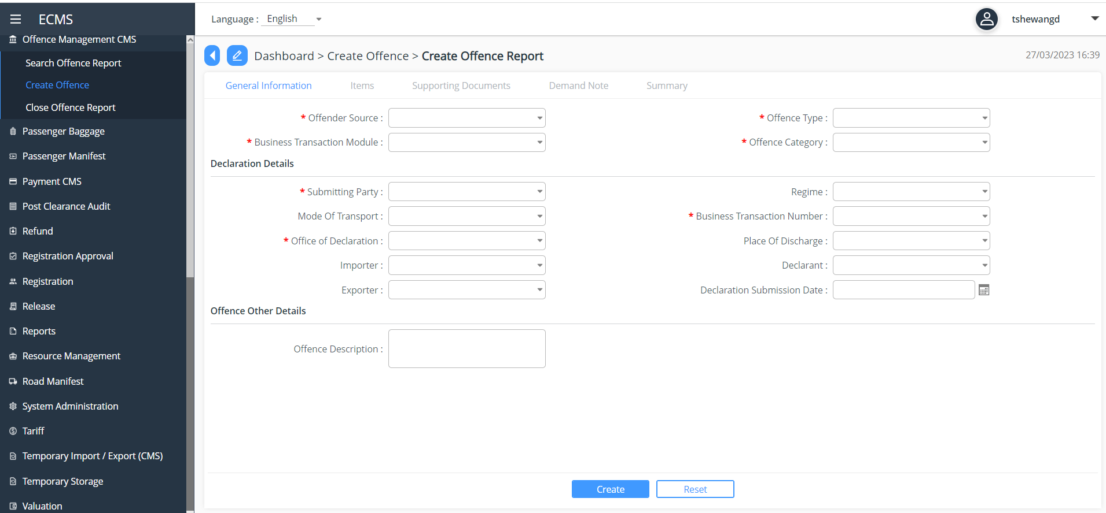

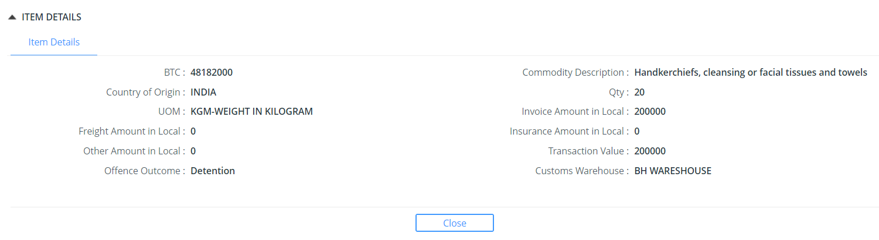

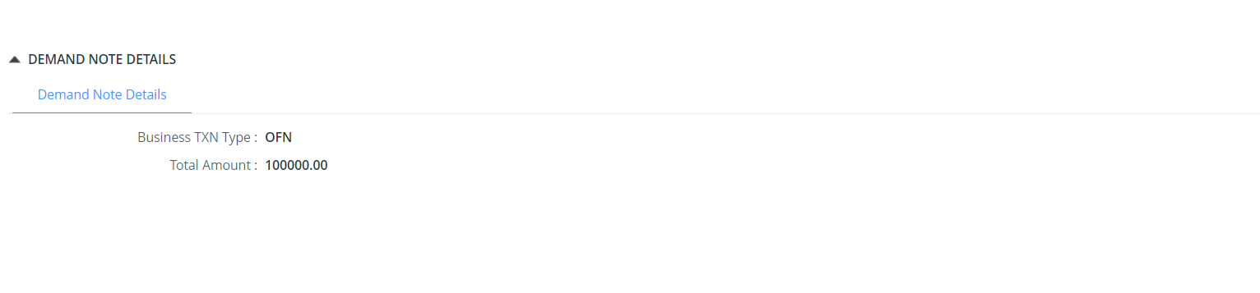

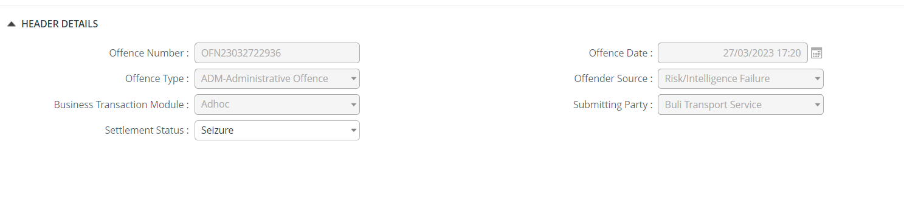

Dependency Viewpoint

The Registration module uses quite a few classes that share information and parameter among themselves to achieve the required functionalities. The package diagram of registration module is provided below.
logging
ORM
data
business
web
Registration Controller
Config
exception
Registration Service
Config
exception
servicehelpers
Registration DAO
Config
exception
daohelpers
mysql-connector.jar
MySQL JDBC Driver
datasource
type
data
values

In the diagram, following dependencies between different packages are shown:
- web package is dependent on the business package,
- business packages depend on the data package and
- ORM package depend on the data package.

These dependencies are explained below:
The Web package of Registration Module contains the Registration Controller class that reads configuration information from a config file and uses the class from the business package to delegate responsibilities. This Registration Service class also gets its configuration information from a different config file and uses service helpers class for doing the business logic processing and Registration DAO class from ORM package for achieving db-centric activities. The service helpers class provides business and data access logic with distributed transaction supports. The Registration DAO class performs the assigned responsibilities depending on dao helpers class and reads a third config file to do so. The dao helpers class accesses the data from the database using a data source. The data source depends on the database driver (mysql-connector.jar), which is supplied externally. The data available in the data package is associated with type and values. All of the dao helpers class from ORM package, the service helpers class from business package and the Registration Controller class from the web package may throw different exception classes at different points of time, which are redirected to the external logging sub-system. This logging sub-system is used for analysing the flow of control of the application.

System Database Schema (er diagram)

ER Diagram
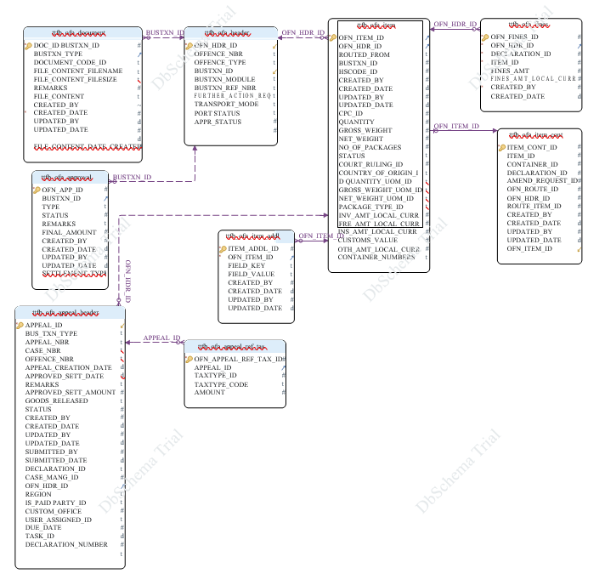

Table Name | Purpose
tbcms_tpr_appl_party_details | <Purpose of the table>
tbcms_tpr_applicant_details
tbcms_tpr_appl_document
tbcms_tpr_appl_checklist
tbcms_tpr_appl_approval
ttfb_tpr_party
ttfb_tpr_user
ttfb_tpr_party_role
ttfb_tpr_party_doc

Field Details

 | Table ttfb_ofn_appeal_header
* Pk | APPEAL_ID | INT
 | BUS_TXN_TYPE | VARCHAR(10)
 | APPEAL_NBR | VARCHAR(35)
 | CASE_NBR | VARCHAR(35)
 | OFFENCE_NBR | VARCHAR(35)
 | APPEAL_CREATION_DATE | TIMESTAMP
 | APPROVED_SETT_DATE | TIMESTAMP
 | REMARKS | VARCHAR(300)
 | APPROVED_SETT_AMOUNT | DECIMAL(16,6)
 | GOODS_RELEASED | VARCHAR(10)
 | STATUS | DECIMAL(3,0)
 | CREATED_BY | DECIMAL(15,0)
 | CREATED_DATE | TIMESTAMP
 | UPDATED_BY | DECIMAL(15,0)
 | UPDATED_DATE | TIMESTAMP
 | SUBMITTED_BY | DECIMAL(15,0)
 | SUBMITTED_DATE | TIMESTAMP
 | DECLARATION_ID | LONGTEXT
 | CASE_MANG_ID | DECIMAL(15,0)
 | OFN_HDR_ID | DECIMAL(15,0)
 | REGION | VARCHAR(30)
 | IS_PAID | VARCHAR(1)
 | PARTY_ID | DECIMAL(15,0)
 | CUSTOM_OFFICE | VARCHAR(15)
 | USER_ASSIGNED_ID | DECIMAL(15,0)
 | DUE_DATE | TIMESTAMP
 | TASK_ID | DECIMAL(15,0)
 | DECLARATION_NUMBER | VARCHAR(35)
 | Table ttfb_ofn_appeal_ref_tax
* Pk | OFN_APPEAL_REF_TAX_ID | INT
 | APPEAL_ID | DECIMAL(15,0)
 | TAXTYPE_ID | DECIMAL(15,0)
 | TAXTYPE_CODE | VARCHAR(10)
 | AMOUNT | DECIMAL(16,6)
 | Table ttfb_ofn_approval
* Pk | OFN_APP_ID | INT
 | BUSTXN_ID | DECIMAL(15,0)
 | TYPE | VARCHAR(10)
 | STATUS | DECIMAL(15,0)
 | REMARKS | VARCHAR(255)
 | FINAL_AMOUNT | DECIMAL(16,6)
 | CREATED_BY | DECIMAL(15,0)
 | CREATED_DATE | TIMESTAMP
 | UPDATED_BY | DECIMAL(15,0)
 | UPDATED_DATE | TIMESTAMP
 | SETTLEMENT_TYPE | VARCHAR(35)
 | Table ttfb_ofn_document
* Pk | DOC_ID | INT
 | BUSTXN_ID | DECIMAL(15,0)
 | BUSTXN_TYPE | VARCHAR(10)
 | DOCUMENT_CODE_ID | VARCHAR(3)
 | FILE_CONTENT_FILENAME | VARCHAR(300)
 | FILE_CONTENT_FILESIZE | DECIMAL(15,0)
 | REMARKS | VARCHAR(255)
 | FILE_CONTENT | LONGBLOB
* | CREATED_BY | DECIMAL(22,0)
 | CREATED_DATE | TIMESTAMP
 | UPDATED_BY | DECIMAL(15,0)
 | UPDATED_DATE | TIMESTAMP
 | FILE_CONTENT_DATE_CREATED | TIMESTAMP
 | Table ttfb_ofn_fines
* Pk | OFN_FINES_ID | INT
* | OFN_HDR_ID | INT
* | DECLARATION_ID | INT
* | ITEM_ID | INT
 | FINES_AMT | DECIMAL(16,2)
 | FINES_AMT_LOCAL_CURR | DECIMAL(16,2)
* | CREATED_BY | DECIMAL(22,0)
 | CREATED_DATE | TIMESTAMP
 | Table ttfb_ofn_header
* Pk | OFN_HDR_ID | INT
 | OFFENCE_NBR | VARCHAR(35)
 | OFFENCE_TYPE | VARCHAR(35)
 | BUSTXN_ID | DECIMAL(15,0)
 | BUSTXN_MODULE | VARCHAR(20)
 | BUSTXN_REF_NBR | VARCHAR(35)
 | FURTHER_ACTION_REQ | VARCHAR(5)
 | TRANSPORT_MODE | VARCHAR(10)
 | PORT | VARCHAR(10)
 | STATUS | DECIMAL(15,0)
 | APPR_STATUS | DECIMAL(15,0)
 | INV_STATUS | DECIMAL(15,0)
 | PARTY_ID | DECIMAL(15,0)
 | OFFENDER_TYPE | VARCHAR(35)
 | OFFICE_CODE | VARCHAR(15)
 | OFFENDER_SOURCE | VARCHAR(35)
 | OFFENCE_DETAILS | VARCHAR(1000)
 | RECEIVING_PARTY_ID | DECIMAL(15,0)
 | OFFENCE_POSITION | VARCHAR(200)
 | GOODS_DELIVERY_ADDR | VARCHAR(200)
 | OFFENDING_ITEM_DELIV_ADDR | VARCHAR(200)
 | DELIVERY_DATE | TIMESTAMP
 | OFFENDING_VEHICLE | VARCHAR(20)
 | VEH_SUSP_DATE | TIMESTAMP
 | VEH_SUSP_RECEIPT_NO | VARCHAR(35)
 | SAMPLE_SENT_TO | VARCHAR(20)
 | PLACE_OF_OFFENCE | VARCHAR(200)
 | Table ttfb_ofn_item
* Pk | OFN_ITEM_ID | INT
 | OFN_HDR_ID | DECIMAL(15,0)
 | ROUTED_FROM | VARCHAR(5)
 | BUSTXN_ID | DECIMAL(15,0)
 | HSCODE_ID | DECIMAL(15,0)
 | CREATED_BY | DECIMAL(15,0)
 | CREATED_DATE | TIMESTAMP
 | UPDATED_BY | DECIMAL(15,0)
 | UPDATED_DATE | TIMESTAMP
 | CPC_ID | DECIMAL(15,0)
 | QUANTITY | DECIMAL(16,6)
 | GROSS_WEIGHT | DECIMAL(16,6)
 | NET_WEIGHT | DECIMAL(16,6)
 | NO_OF_PACKAGES | DECIMAL(8,0)
 | STATUS | VARCHAR(10)
 | COURT_RULING_ID | DECIMAL(15,0)
 | COUNTRY_OF_ORIGIN_ID | VARCHAR(2)
 | Table ttfb_ofn_item_addl
* Pk | ITEM_ADDL_ID | INT
* | OFN_ITEM_ID | DECIMAL(22,0)
 | FIELD_KEY | VARCHAR(50)
 | FIELD_VALUE | VARCHAR(500)
 | CREATED_BY | DECIMAL(15,0)
 | CREATED_DATE | TIMESTAMP
 | UPDATED_BY | DECIMAL(15,0)
 | UPDATED_DATE | TIMESTAMP
 | Table ttfb_ofn_item_cont
* Pk | ITEM_CONT_ID | INT
 | ITEM_ID | DECIMAL(15,0)
 | CONTAINER_ID | DECIMAL(15,0)
 | DECLARATION_ID | DECIMAL(15,0)
 | AMEND_REQUEST_ID | DECIMAL(15,0)
 | OFN_ROUTE_ID | DECIMAL(15,0)
 | OFN_HDR_ID | DECIMAL(15,0)
 | ROUTE_ITEM_ID | DECIMAL(15,0)
 | CREATED_BY | DECIMAL(15,0)
 | CREATED_DATE | TIMESTAMP
 | UPDATED_BY | DECIMAL(15,0)
 | UPDATED_DATE | TIMESTAMP
 | OFN_ITEM_ID | DECIMAL(15,0)

